

Respected Mam/Sir,

I hope this email finds you well.

We, DivinStudio, are delighted to introduce ourselves as a dynamic and innovative packaging solution provider that is consistently thriving to enhance our customers’ experience for their diversified packaging needs. Established in 2019, continuing delivering our services to renowned customers in the field of manufacturing ranging from Automotives, Ecommerce, Cosmetics, Food and many more.

Our Solution spectrum covers the following categories with specialization in the Mono Cartons and Outer Carton Boxes. We also have Nail-less wooden boxes of export quality for Logistics / Transportation packaging purposes.

**Shipping / Logistics packaging**(Heavy cartons, wooden crates)

1. Master Carton Packaging boxes (Plain / Printed / Branded)

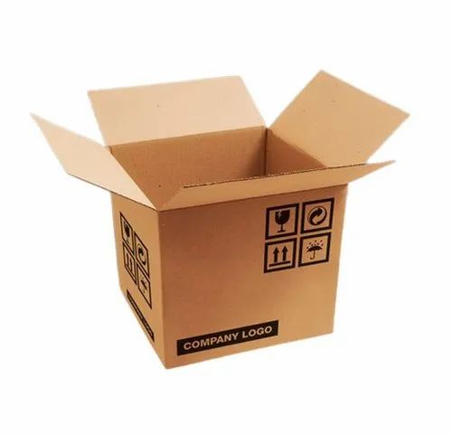

1. Nail-less Wooden Packaging boxes

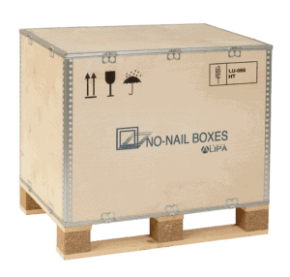 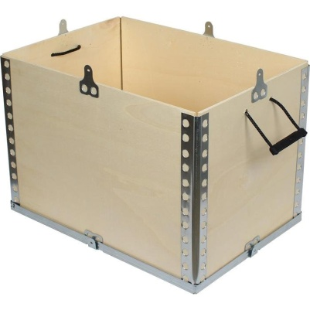

1. Honey Comb Packaging (Pallets, Boxes)

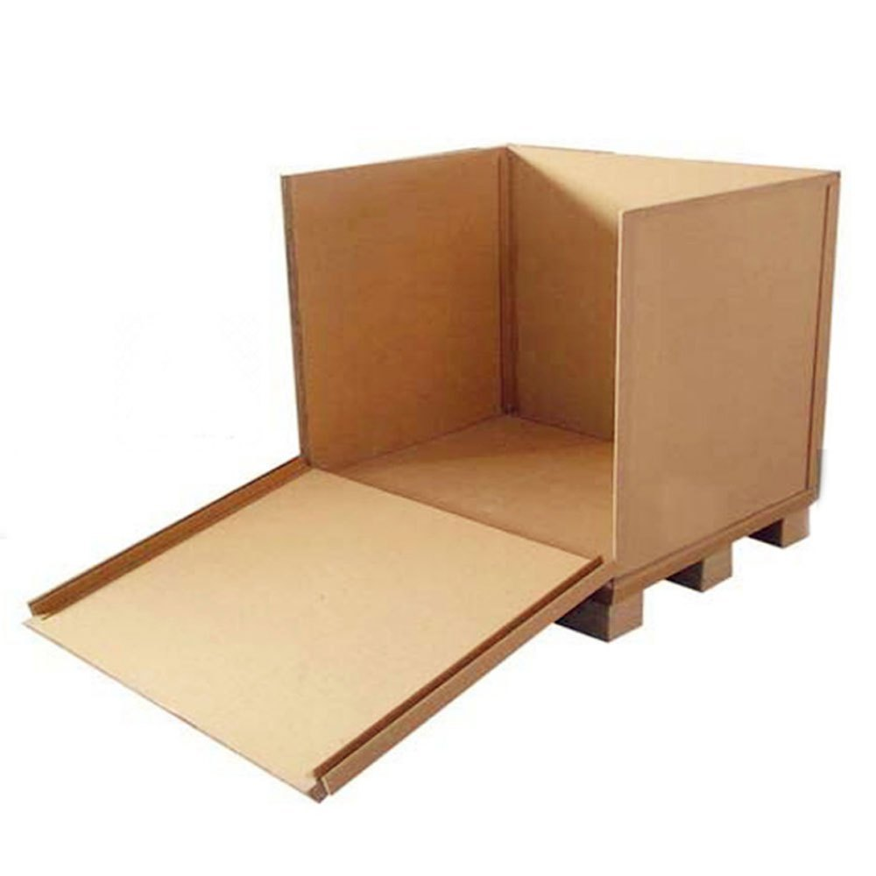 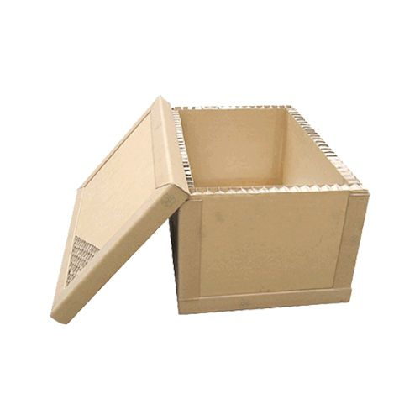

**Product Packaging (Mono Cartons)**

1. **Food Industry**
2. Vegetables/ Fruits Packaging Boxes

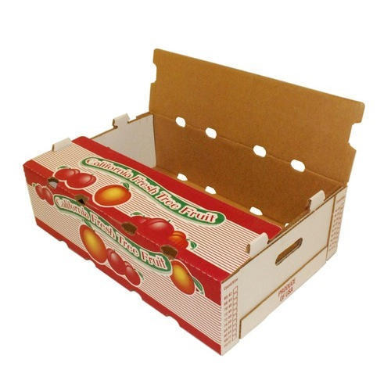 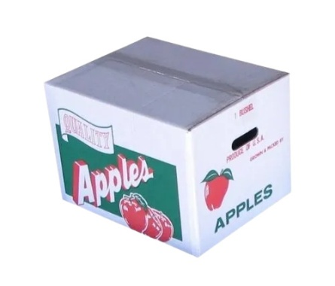 

1. **Automotive Industry**
2. Spare parts boxes(Head Lamps, Motors, Tail Lights, Horns, Tapes)

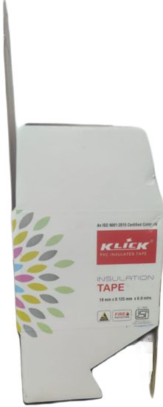 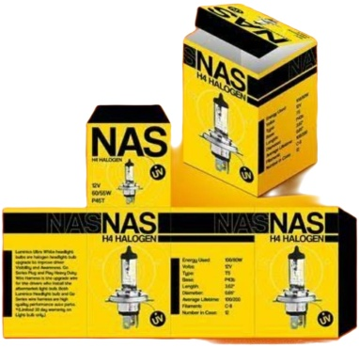

1. Wires boxes

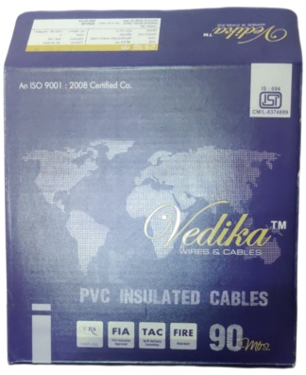 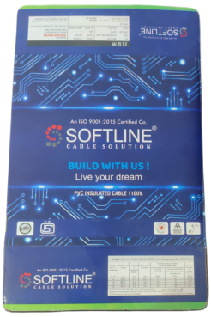 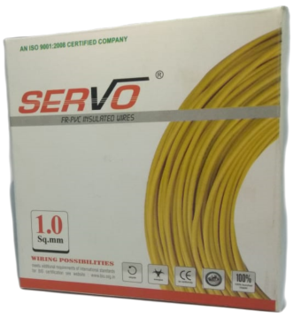

1. Other Spares parts (Connectors boxes)
2. **Ecommerce Industry**
3. Online order fulfillment boxes (Food and vegetables online delivery)
4. Ecommerce Groceries Deliveries
5. Ecommerce Fashion

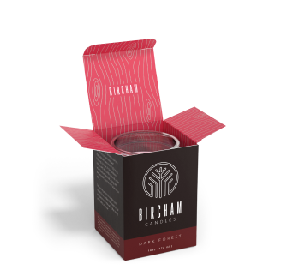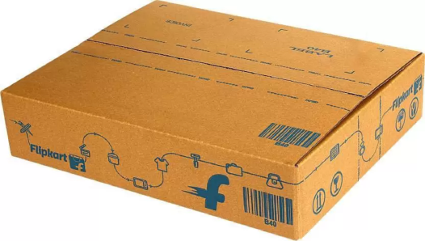

1. **Liquor Industry**
2. Liquor Product Packaging boxes
3. Liquor Master Corrugated boxes

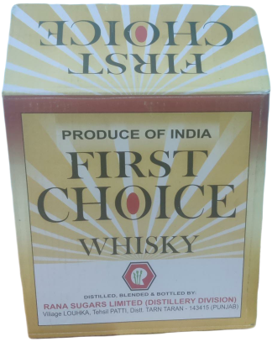 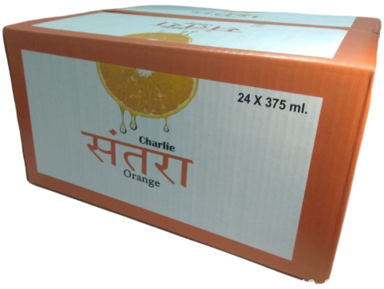

1. **Cosmetics Industry**
2. Cosmetics products (Creams, Facial Packages, Massage products boxes)

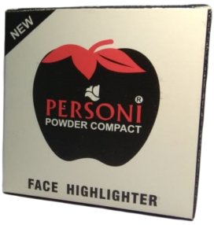 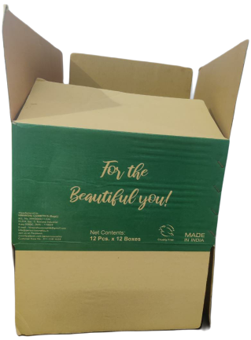 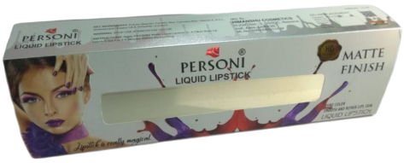

1. **Electrical Appliances**
2. Electrical goods and gadgetries

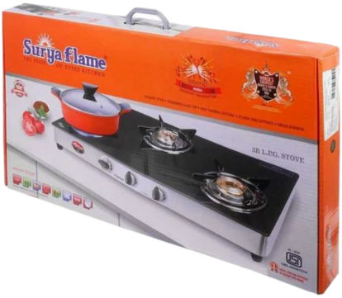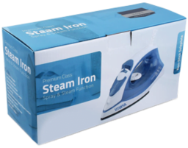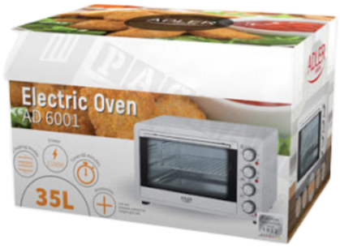

1. **White Goods**
2. White goods outer covering carton boxes



**Clientele**

RSL Distilleries, Personi Cosmetics, Empire Cables, Klick Electrical Industries, Hella etc.

As a responsible business house we have all pre requisite sanctions, licences and tax registrations to ensure transparent dealing with regards to regular business compliance.

We request you to please help us serve you and develop a positive business relationship with your esteemed organization.

Regards,

Sales Team, DivinStudio

Mob. + 91 8527427509, + 91 9467316873

Registered Address :

297, Sector – 15, Sonipat, Haryana - 131001